Evaluation of connectives between color and typical adjective metaphor
in Japanese language.

Takashi Yamazoe¹, Yhuki Gouma², Yoshihiko Azuma³

1. Institute for Global Prominent Research, Chiba University
1-33 Yayoi-cho
Inage-ku, Chiba-shi, Chiba, Japan
yamazoe@chiba-u.jp

2. Department of Media and Image Technology Tokyo Polytechnic University
1583 Iiyama
Atsugi-shi, Kanagawa, Japan
magmax1217@gmail.com

3. Department of Media and Image Technology Tokyo Polytechnic University
1583 Iiyama
Atsugi-shi, Kanagawa, Japan
azuma@mega.t-kougei.ac.jp

Abstract

Color is able to appreciate and easy for us. Many people use color to explain typical character of some material object. People understand color is one of representative material object character. However, color and color adjective metaphor has no common point. Because, it is not clarified about color and adjective metaphor connectives. In this study, authors tried to clarify connectives between color and adjective metaphor categories. Subjective evaluation was used to clarify connectives.

Keywords; color; adjective; metaphor; evaluation; subjective

I. Introduction

Our impression was conveyed by word from information through our sensibility. About 70% perception is came from visibility. Especially, color is easy and understandable element for us._{[1]} Therefore, many people use to color to explain typical character of some material object._{[2]} People understand color is one of representative material object character._{[3]} Thus, color is recalled by material object and this relation is called color recall. Color recall is constructed by two factors as color and adjective metaphor._{[4]} Adjective metaphor occurs from color and some material object. Material object has typical significances including color. Typical significances are expressed by adjective metaphor._{[5]} This typical significances of adjective metaphor affect recall of color. After all, color is related to some adjective metaphor. Such metaphor is called color adjective metaphor. Color adjective metaphor is often used in graphic design to provide some product impression. Color adjective metaphor is one of benchmark in color scheme decision. However, color and color adjective metaphor has no common point in many peoples. Therefore, color scheme design is not always matched with product image. Because, it is not clarified about color and adjective metaphor connectives. In this study, authors tried to clarify connectives between color and adjective metaphor categories. Subjective evaluation was used to clarify connectives.

II. Method

A. Purpose

Relation among color and adjective metaphor category were evaluated by subjective evaluation using seven scale questionnaire. 36 colors were used in evaluation. These colors base on categorical color with different value. 39 typical adjective metaphor categories were used in evaluation. These adjective metaphor categories were classified from meaning of adjective metaphor in Japanese language.

B. Subject

Ten subjects include eight males and two females. Range of age was 20 to 23 (the average was21.4 years of age). All of the subjects had normal visual acuity, either natural or corrected using glasses or contact lens (binocular sight was 1.0 or greater, and their color vision was confirmed by Ishihara test plate.). Subjects were provided with a thorough explanation regarding the purpose and the methods, and their consent was obtained prior to the experiment.

C. Apparantus and stimulus

Color stimuli was made 36 colors based on categorical color with different value. Color stimulus was made by Adobe Photoshop CC. Color was chosen from web safe color without hard to distinguish color by preliminary experiment (seven subjects observed). 36 colors were included black and five scale brightness with seven hue included, Gray, Red, Orange, Yellow, Green, Blue and Purple. All colors were able to distinguish subjectively._{[6][7]} Objectively, eleven brightness scale were used in color stimulus. (All colors were set five scale brightness subjectively. Because, some color is able to look different hue on objective brightness scale used.) Each color stimulus has 5 degree of visual angle of regular square from 50cm distance. Color stimulus was shown central viewing area. Because, memory of the central detail information of the emotional condition was better._{[8]}
Back ground of color stimulus was used L*=50 gray color measured by spectrophotometer (Topcon, SR-3A, fig1). Color stimuli was shown by 24 inch LCD Display (EIZO, Color Edge CG248-4K, 185ppi) and computer (Apple, Mac mini 2014). Color space was set adobe RGB color space (6500K, gamma 2.2). Display and computer were connected by Display Port cable for use 10 bit color.
39 adjective metaphor categories were classified from typical meanings of Japanese language. _{[8]}39 adjective metaphor categories included, deep-shallow, thick-thin, simple-detail, heavy-light, hard-soft, durable-brittle, high-low, rough-smooth, sharp-dull, strong-weak, wide-narrow, large-small, far-near, long-short, loose-tight, new-old, fast-slow, taste, tactile, visibility, smell, hearing, danger-safe, showy-quiet, beauty-ugly, difficult-easy, correct-wrong, good-bad, smart-silly, glamorous-shabby, dainty-unrefined, extreme-moderate, behavior, busy-free, emotion, temperature, painful, many-few and rich-poverty. 39 adjective metaphor categories were evaluated by seven scale of recall relation check sheet. Recall relation check sheet was shown and answered by tablet computer (Apple, iPad 4th generation). Seven scales were used pull down select menu. Seven scales was used only check connectivity of adjective metaphor categories. But, it is not check for extent of adjective metaphor category. Subjective evaluation was executed in dark room.


Fig.1 Sample of color stimulus with background.

D. Procedure

Subject was sat in darkroom from 50cm of display.(Fig. 2) Subject has adaptation time about 30 minutes. Since adapt time, color stimulus was shown and Subject was started answer color and adjective metaphor recall relation used tablet computer with seven scale check sheet on 39 adjective metaphor categories. Subject finished answer, color stimulus disappeared 30 second and after appeared next color stimulus. 30 second blank time was set for restraining previous color affect to subject impression. Subject was answered all of 36 colors. Color stimulus has no limit time to shown subject till finish their answer. Color stimulus was shown at random between subjects. If subject has question, then assistant answer the question.

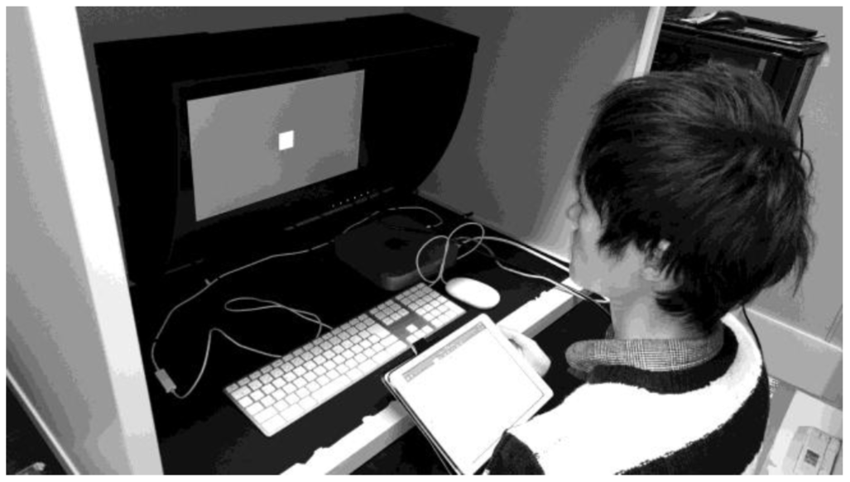
Fig.2 Subject observed color stimulus
E. Analysis

One-way ANOVA was used to compare the subjective evaluation. Multiple comparison of Bonferroni test was use to compare each factors of adjective metaphors, hue and value.

F. Results

Result was shown in figures. (Fig. 3-Fig. 5) Results were shown that higher score of adjective metaphor categories were, deep-shallow, thin-thick, heavy-light, hard-soft, new-old, visibility, danger-safe, showy-quiet, beauty-ugly, dainty-unrefined, emotion and temperature. (P<.01, F=24.73, Fig. 3) Adjective metaphor categories of high-low, rough-smooth, far-near, long-short, fast-slow, smell, hearing, painful and many-few is low score from 36 colors. Results of compare of hue was shown purple is low score than other colors. (P<.01, F=9.71, Fig. 4) Results of value shown, high brightness levels of 192, 216 and 240 were low score to adjective metaphor. (P<.01, F=4.359, Fig. 5) Results were shown each adjective metaphor categories has different connectivities of recalling between colors.

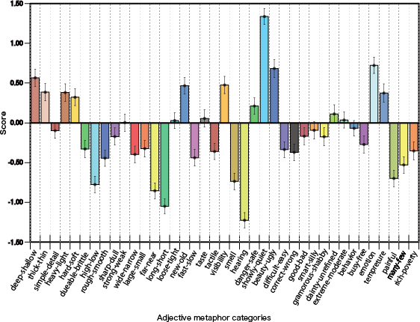
Fig. 2 Results of each adjective metaphor connectivities between all of 36 colors. (error bar is S.E.)

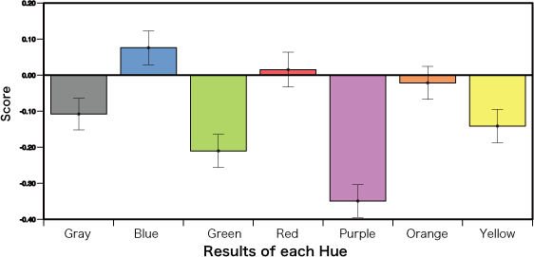
Fig. 3 Results of each hue of score. (error bar is S.E.)

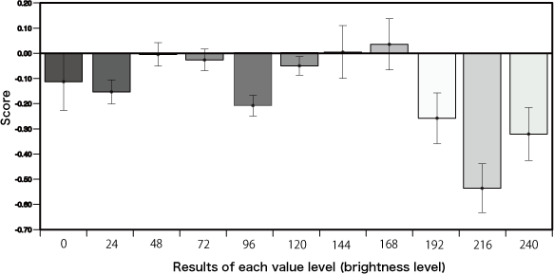
Fig. 4 Results of each value of score. (error bar is S.E.)

III. Discussion

Results were suggested adjective metaphor categories of deep-shallow, thin-thick, heavy-light, hard-soft, new-old, visibility, danger-safe, showy-quiet, beauty-ugly, dainty-unrefined, emotion and temperature has strong connectivities between 36 colors. These strong connect of adjective metaphors were able to thought color is most important factor to judgement their categories. On the other hand, adjective metaphor categories of high-low, rough-smooth, far-near, long-short, fast-slow, smell, hearing, painful and many-few were able to thought that does not depend on colors to judgement. Adjective metaphor categories of high-low, rough-smooth, far-near, long-short, fast-slow and many-few were used to judge by numerical value or geometry of visibility, and categories of smell, hearing and painful were not used to judge by visibility. These results are suggest important factor is recall stronger to connect some kind of metaphor. Purple was low score in results of hue. It is thought purple is difficult to distinguish than other six hue categories. Because, purple is darker than other six hue categories on web safe color. Higher brightnesses are low score in results of value. At web color of high value stimuli, chroma is going to higher too. It is thought that subject feel vivid extremely in dark room. However, results of score is not huge affect by color factors of hue and value. This suggests specific color influence does not define color recalling between adjective metaphors. Moreover, it is thought color recalling between adjective metaphors needs several color to connect adjective metaphor.

IV. Conclusion

Results of subjective evaluation were suggested adjective metaphor and color connectivity is depend on important factor of judgement some condition. It is thought color is represent typical statement on adjective metaphor. These statement is able to connect color and adjective metaphor. However, results suggest color is not always recall adjective metaphor. It is thought one of reason of mismatch in color scheme design. If used non color recalling adjective metaphor, it is hard to recall color. In this design case, product image is provided by geometric design or other sensibilities to recall image of adjective metaphor. In this research, only evaluated by Japanese young ages. Color and adjective metaphor is affect from grammar and cultural background. It is suggest that can be seen other connectivities in other countries._{[10]} If one discovers common connectivities between color and adjective metaphor, design of color scheme is more useful for us.

References

[1] Kennedy, C., & McNally, L. (2010). Color, context, and compositionality. Synthese, 174(1), 79-98.
- Kress, G., & Van Leeuwen, T. (2002). Colour as a semiotic mode: Notes for a grammar of colour. Visual communication, 1(3), 343-368.
- Sherman, G. D., & Clore, G. L. (2009). The color of sin: White and black are perceptual symbols of moral purity and pollution. Psychological Science, 20(8), 1019-1025.
- Werning, M., Fleischhauer, J., & Beseoglu, H. (2006). The cognitive accessibility of synaesthetic metaphors. In Proceedings of the Twenty-Eighth Annual Conference of the Cognitive Science Society(pp. 2365-2370). London: Lawrence Erlbaum.
- Gentner, D. (1983). Structure‐mapping: A theoretical framework for analogy. Cognitive science, 7(2), 155-170.
- Goldstone, R. L. (1995). Effects of categorization on color perception. Psychological Science, 6(5), 298-304.
- Harman, G. (1996). Explaining objective color in terms of subjective reactions. Philosophical issues, 7, 1-17.
- Christianson, S. Å., Loftus, E. F., Hoffman, H., & Loftus, G. R. (1991). Eye fixations and memory for emotional events. Journal of Experimental Psychology: Learning, Memory, and Cognition, 17(4), 693.
- Akira Utusmi, Maki Sakamoto. (2006). Adjective metaphor is able to understand by 2steps of categories. The Japanese Society for Artificial Intelligence 24th language engineeringstudies,13-20.
- Werning, M., Fleischhauer, J., & Beseoglu, H. (2006). The cognitive accessibility of synaesthetic metaphors. In Proceedings of the Twenty-Eighth Annual Conference of the Cognitive Science Society(pp. 2365-2370). London: Lawrence Erlbaum.

